Vocab Chapter 9 The 17th Century: 1600-1700

1. Balagny Cloak- Lauren Shumway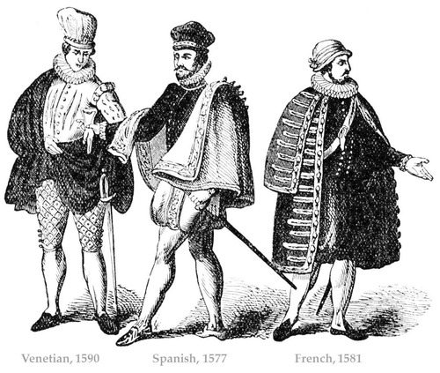

A balagny cloak also known as Spanish capes. The cloak was circular in shape and had wide collars useal worn on one shoulder and secured with a cord that would pass under the collar

The Book

<https://fashionhistory.fitnyc.edu/spanish-cape/>

https://bsamply.com/encyclopedia/balagny-cloak/

1. Basque- Abbie Burns 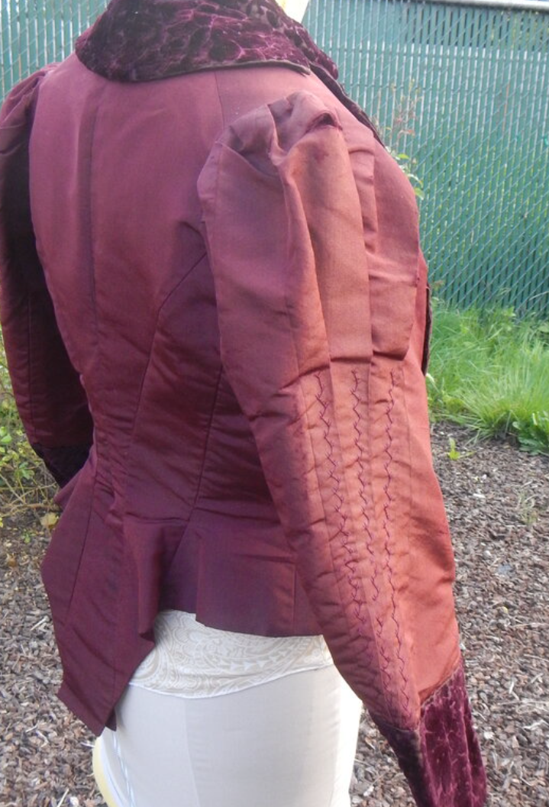

The bodice included a long, wide basque this was an extension of the bodice below the waist line. The long tailed “jackets” were used to ensure a couture fit. It is also called a closely fitted bodice. Women who would wear a basque would never do any manual labor with their arms or shoulders because of the constriction.

Sources:

Book pg:242

<https://en.wikipedia.org/wiki/Basque_(clothing)>

https://www.robesdecoeur.com/blog/1880s-basque-bodice

1. Biggin- Jessica Fraser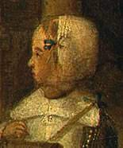

A cap that is closely fitted. This was normally worn by children. It was worn at night while sleeping. It tied under the chin to keep it from slipping. I thought it was interesting how in the video it explained the importance of hair at events. That buns were slicked back, and when needed the face was framed with curls.

The Book

<https://www.dictionary.com/browse/biggin#:~:text=noun%20Archaic.,cap%20worn%20while%20sleeping%3B%20nightcap>

[(Links to an external site.)](https://www.dictionary.com/browse/biggin#:~:text=noun%20Archaic.,cap%20worn%20while%20sleeping%3B%20nightcap)

<https://www.patternsoftime.com/proddetail.php?prod=MRBiggin>

1. Breeches- **Ryann Becker**

This term continues until the present however over time the shape and cut have varied. They had completely replaced trunk-hose in England by about 1620 and were the most common form of legwear. Breeches were made with a seam on the inside and outside of the leg and varied in fullness. They were fastened to the knee with ribbon, garner, or buttons. While hose or stockings still covered the lower half of men's legs. 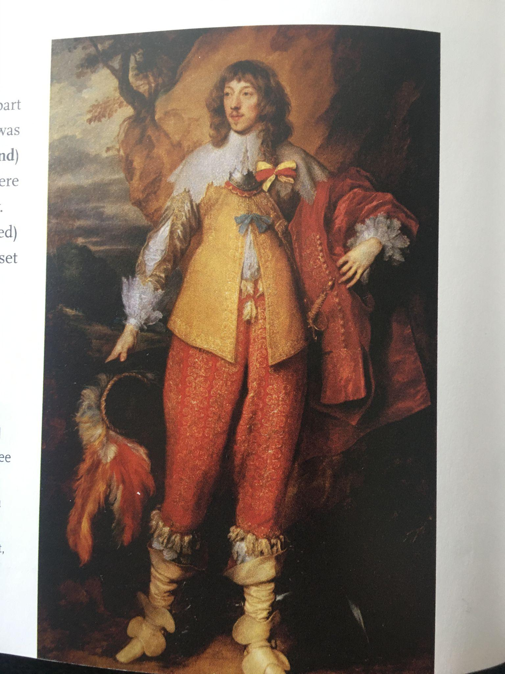

Textbook page 245

[http://www.fashionencyclopedia.com/fashion_costume_culture/European-Culture](http://www.fashionencyclopedia.com/fashion_costume_culture/European-Culture-17th-Century/Breeches.html#:~:text=Breeches%20remained%20the%20most%20common,men%20in%20the%20seventeenth%20century.&text=The%20breeches%20were%20fastened%20at,lower%20half%20of%20men's%20legs)

<http://nationalclothing.org/786-17th-century-petticoat-breeches-%E2%80%93-these-male-pants-are-so-lady-like,-it-hurts.html>

1. Canons - Debbi Wright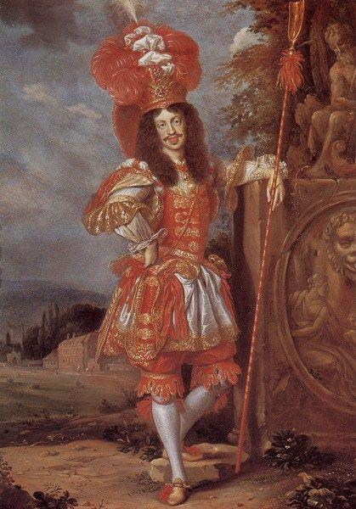

Our textbook tells us that canons are a full,wide ruffle attached at the bottom of breeches. “Canons were usually attached as decorative additions to the stockings, and when worn almost always accompanied petticoats or open breeches, and were never worn with closed breeches.”

Toratora, Phyllis G, and Keith Eubank. *Survey of Historic Costume, 5th Edition*. Berg, 2009.

<https://fashionhistory.fitnyc.edu/1660-1669/>

<https://www.google.com/search?q=canon+seventeenth+century+clothing&rlz=1C1CHBD_enUS882US882&source=lnms&tbm=isch&sa=X&ved=2ahUKEwiC5oqgpfP1AhVyKEQIHTLPDDAQ_AUoAnoECAEQBA&biw=1229&bih=577&dpr=1.56#imgrc=My1cn2Jryw_H1M>

1. Capotain- Kya Boyd 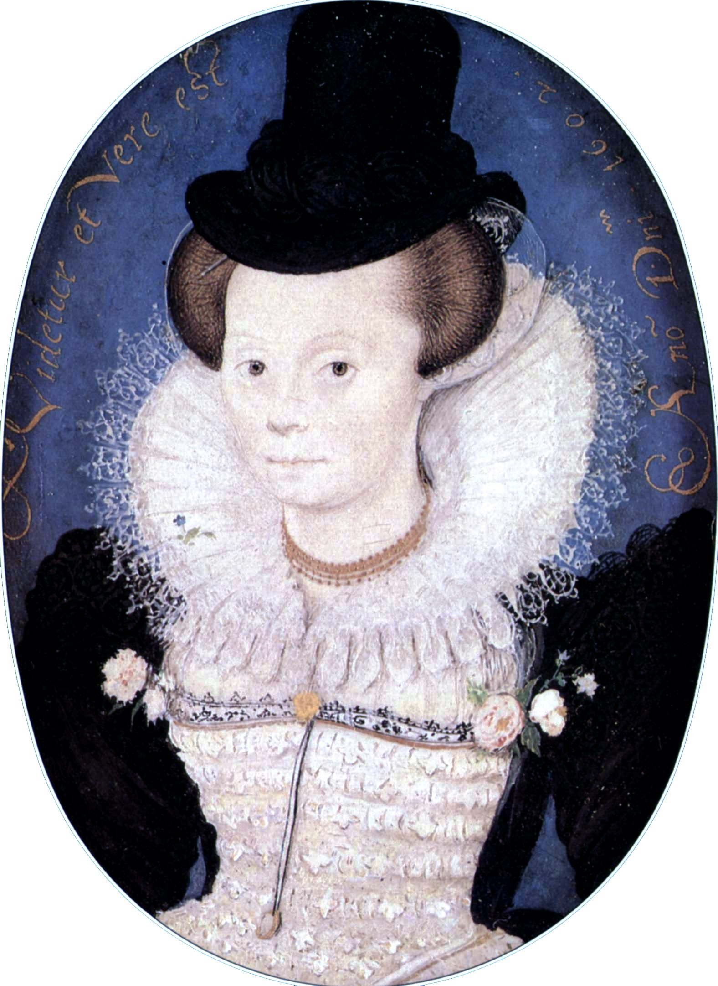

This is a tall- crowned narrow brimmed slightly conical hat that is normally black since that is the trend. The top of the hat used to be round but in the 17th century it evolved to a flat top of the hat. This is said to be the predecessor of the top hat women and men wear in all social classes and continued to wear until wigs started to grow into fashion. This hat stayed in fashion from the 1590’s to the 17th century in England and North Western Europe associated with Puritan costume.

Sources:<https://en-academic.com/dic.nsf/enwiki/3914048>

<https://typesofhats.com/hat/capotain/>

Survey of Historic Costume

1. Carrying Frock/Going Frock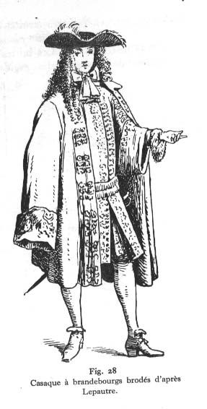
2. Cassock, Casaque: Lexie Pincock

It is French for “long robe”. Ankle-length robe/coat cut with wide, full sleeves. They were wide throughout the length of the body and ended no shorter than the height of the thigh. It was mostly worn by clerics and ministers.

Pg. 244

<https://en-academic.com/dic.nsf/enwiki/196363>

<https://www.wikiwand.com/en/Cassock>

1. Commode - Jensen Stenquist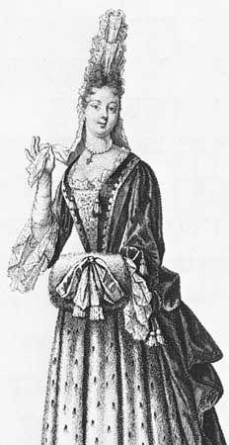

On top of the hair women placed a device made up of ruffles held in place with sire supports and known as fontange in France and known as the commode in England and the American colonies. Over a period of about thirty years, the style evolved from a small bow tying up the hair in front to an elaborate, tall structure of 3 or 4 lace tiers in front and a cascade of ruffles and bows in the back. It had its beginning when a favorite of Louis XIV whose hair had become untidy while hunting, tied it up with a garter ribbon.

http://demodecouture.com/hairstyles-cosmetics-18th-century/

<https://www.britannica.com/topic/commode-headwear>

The book

1. Cravat- Abigail Storrer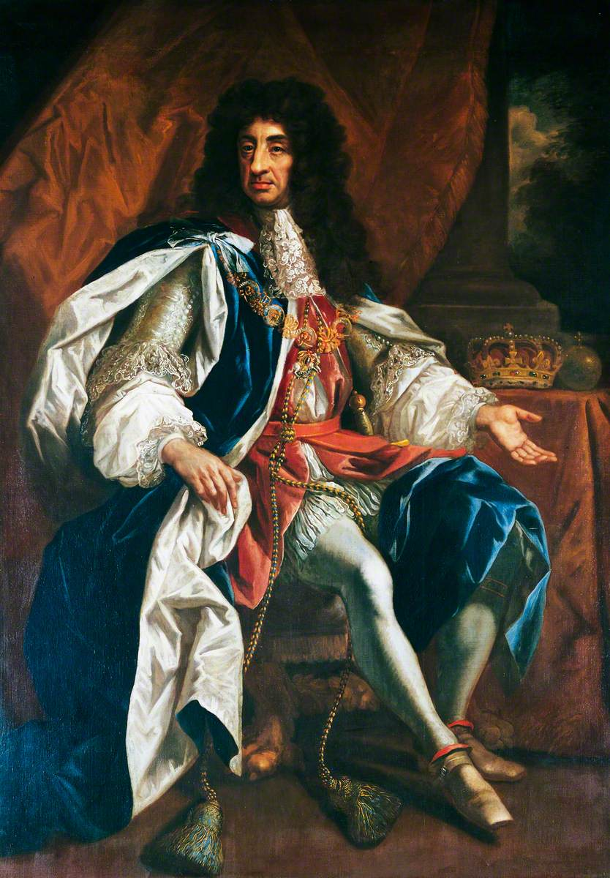

In 1680, the cravat made a greater appearance in men’s fashion and began to replace collars. The cravat is thought to have come from the influence of Croatia when some of them were serving in the French military. King Louis the 13th noticed and later the style was brought into fashion by Charles the 2nd. It is also thought to be a precursor to ties. They were made out of strips of fabric or lace.

Tortora, P. G., & Eubank, K. (2010). *Survey of historic costume: A history of western dress*. Fairchild.

<https://tourdalmatia.com/history-tie-croatia-cravat/>

<https://turnbullandasser.com/blogs/off-the-cuff/off-the-cuff-history-of-neckwear>

<https://artuk.org/discover/artworks/king-charles-ii-16301685-28385>

1. Diapers-
2. Draw Loom - Jocelyn Munoz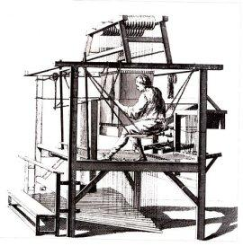

The drawloom was a machine used to weave complicated patterns on silk fabric. It’s assumed it was created in China but it was in use in Italy around 1600. The machine required a young child to sit on top of the loom and manually raise and lower sets of yarns but an improvement allowed the child to sit to the side and easier raise and lower the threads. This machine allowed silk fabrics to be readily available.

Tortora, P. G., & Marcketti, S. B. (2021). A survey of historic costume. essay, Fairchild Books.

<https://www.britannica.com/technology/drawloom>

<https://recycleddress.wordpress.com/2014/03/11/the-drawloom/>

1. Falling Band- Claire Moore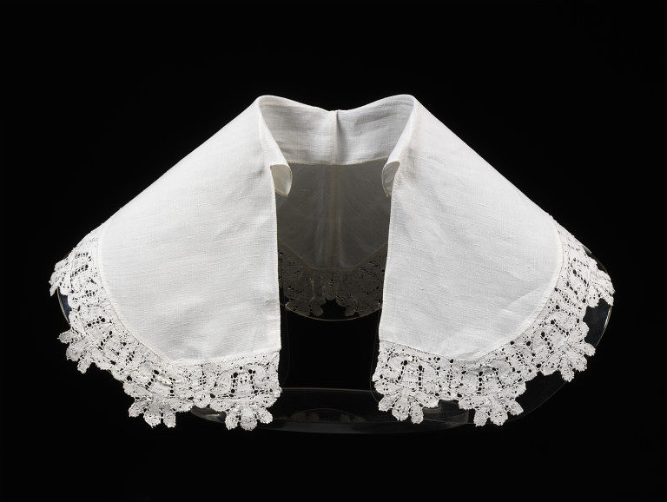

The falling band was a white flat collar that was tied around the neck. It was primarily worn by men at this time and replaced the ruff. While the shirt was often very full the collar was a flat piece to put on top.

Source-

<https://fashionhistory.fitnyc.edu/falling-band/>

<http://www.fashionencyclopedia.com/fashion_costume_culture/European-Culture-17th-Century/Falling-and-Standing-Bands.html>

Page - 244

1. Fontange- Savannah Tanner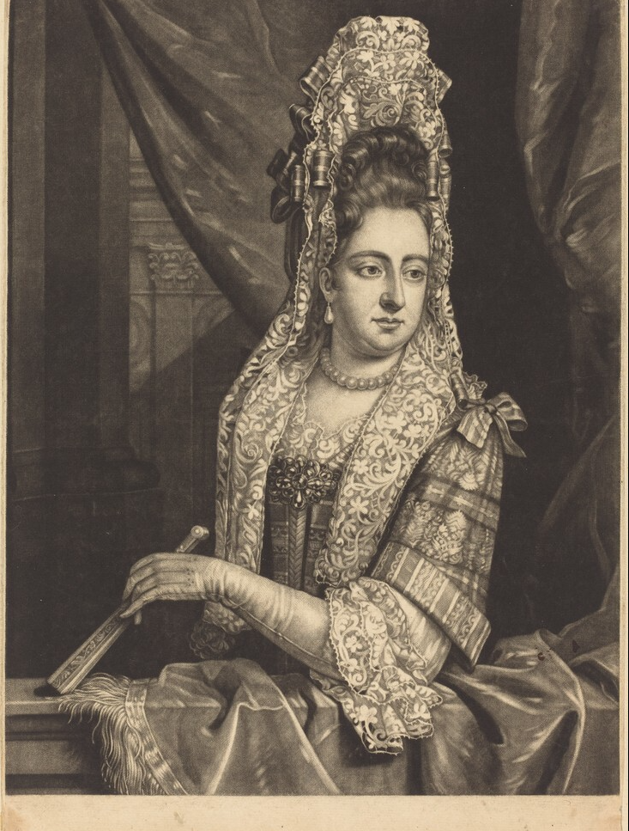

The fontange (or commode) was a hair accessory that was worn atop a stack of hair that was piled on your head. The fontange was an accessory that evolved over the years from a small bow accessory used to tie hair, into a complicated arrangement of lace. The lace was tiered in the front, and cascaded with ruffles and bows down the back. The style may have been named after a mistress of Louis XIV. As a result of her dishevelment after an encounter with Louis XIV, she used her lace garter to tie her hair up. The fontange is affixed with wire to keep it in place.

<https://fashionhistory.fitnyc.edu/fontange/>

<https://www.wise-geek.com/what-is-a-fontange.htm>

Pg 256

1. Galosh - Alex Clark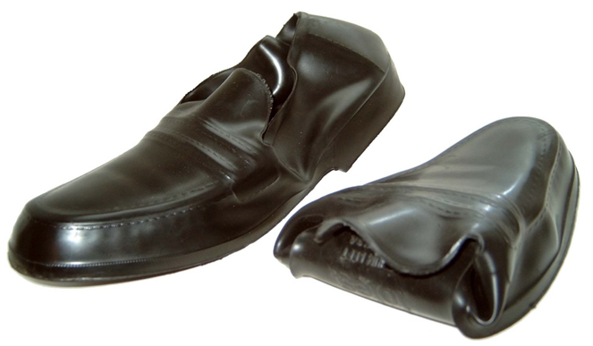

The galosh was a flat-soled overshoe with a toe cap to keep it in place. They were used as a protective layer over the original shoe to protect it from the effects of weather. It was also traditionally made with leather or wood to protect from the elements.

Sources:

Survey of Historic Costume, Page 248

<https://en.wikipedia.org/wiki/Galoshes>

<http://www.kipar.org/archive/baroque-costumes/costumes_male_footwear.html>

1. Guardinfante-Jamie Rakes

A guardinfante is what the Spanish style of dress was called. It was similar to the French Farthingale, however the guardinfante was more oval than the Farthingale. It was typically made from a rigid material that limited motion, therefore meaning a top needed to be made to also limit the motion. Even though it was oval it was soon changed to be rectangular. The translation of a guardinfante literally means to hide the infant.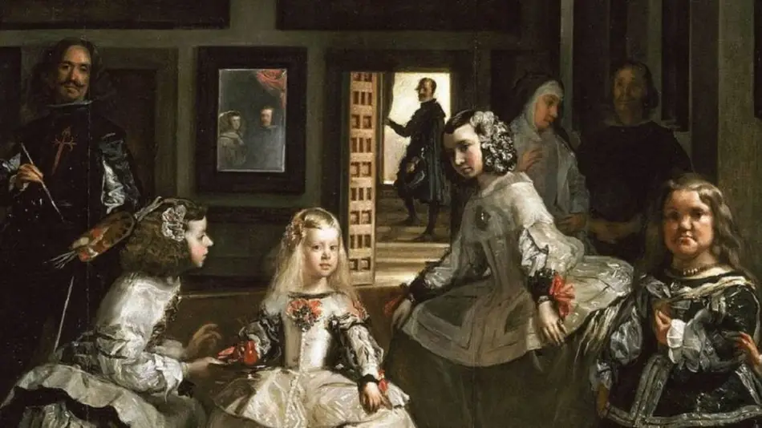

<https://historydelights.com/2021/01/24/spanish-farthingale-in-the-17th-century-womens-body-controlled-through-fashion-2/>

<https://thecolorainbow.wordpress.com/2009/10/31/17-century/>

The book pg 171

1. Jack Boots - Amanda Hair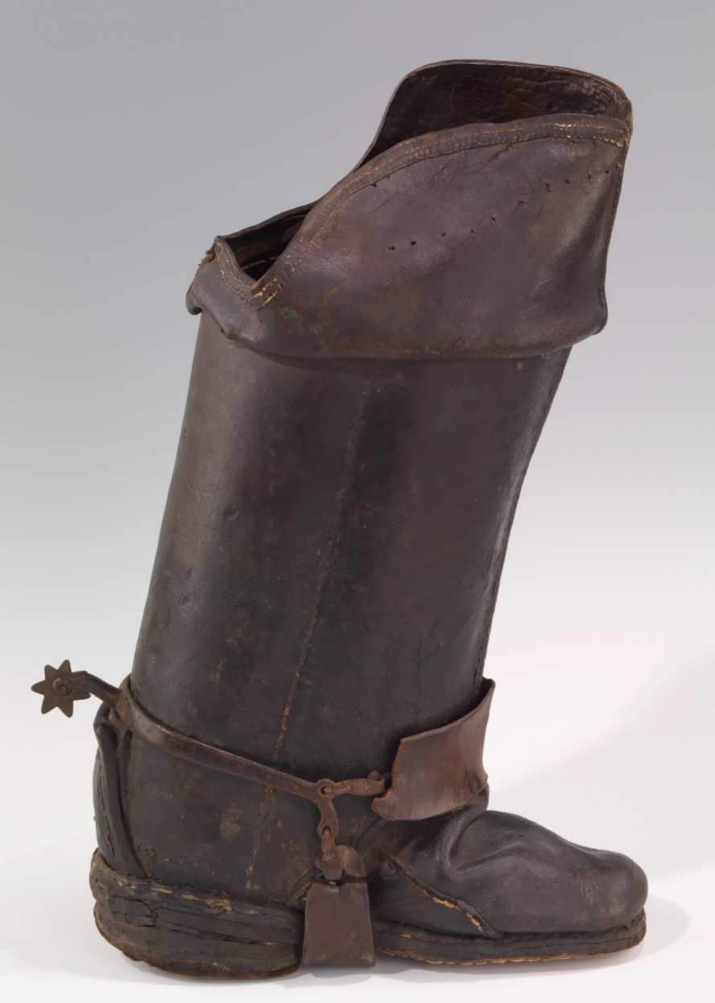

Jack Boots are made of very heavy, stiff, leather. These boots protected the postillion rider’s legs very well but were not good for walking in. Jacked leather was horsehide that was treated with wax and tar which made it waterproof and colored it black. Boots were in some crowds a popular fashion for both men and women at this time, not to mention their functionality. There is a rumor that boots like these became popular in the English court because young Charles had used a boot-like shoe apparatus to learn to walk. In general however, shoes were still preferred to boots. These boots would have been worn riding with knee-length stockings and knee breeches.

<https://www.metmuseum.org/art/collection/search/157647>

<http://historyofboots.blogspot.com/2009/06/seventeenth-century-boots.html>

Textbook Page: 250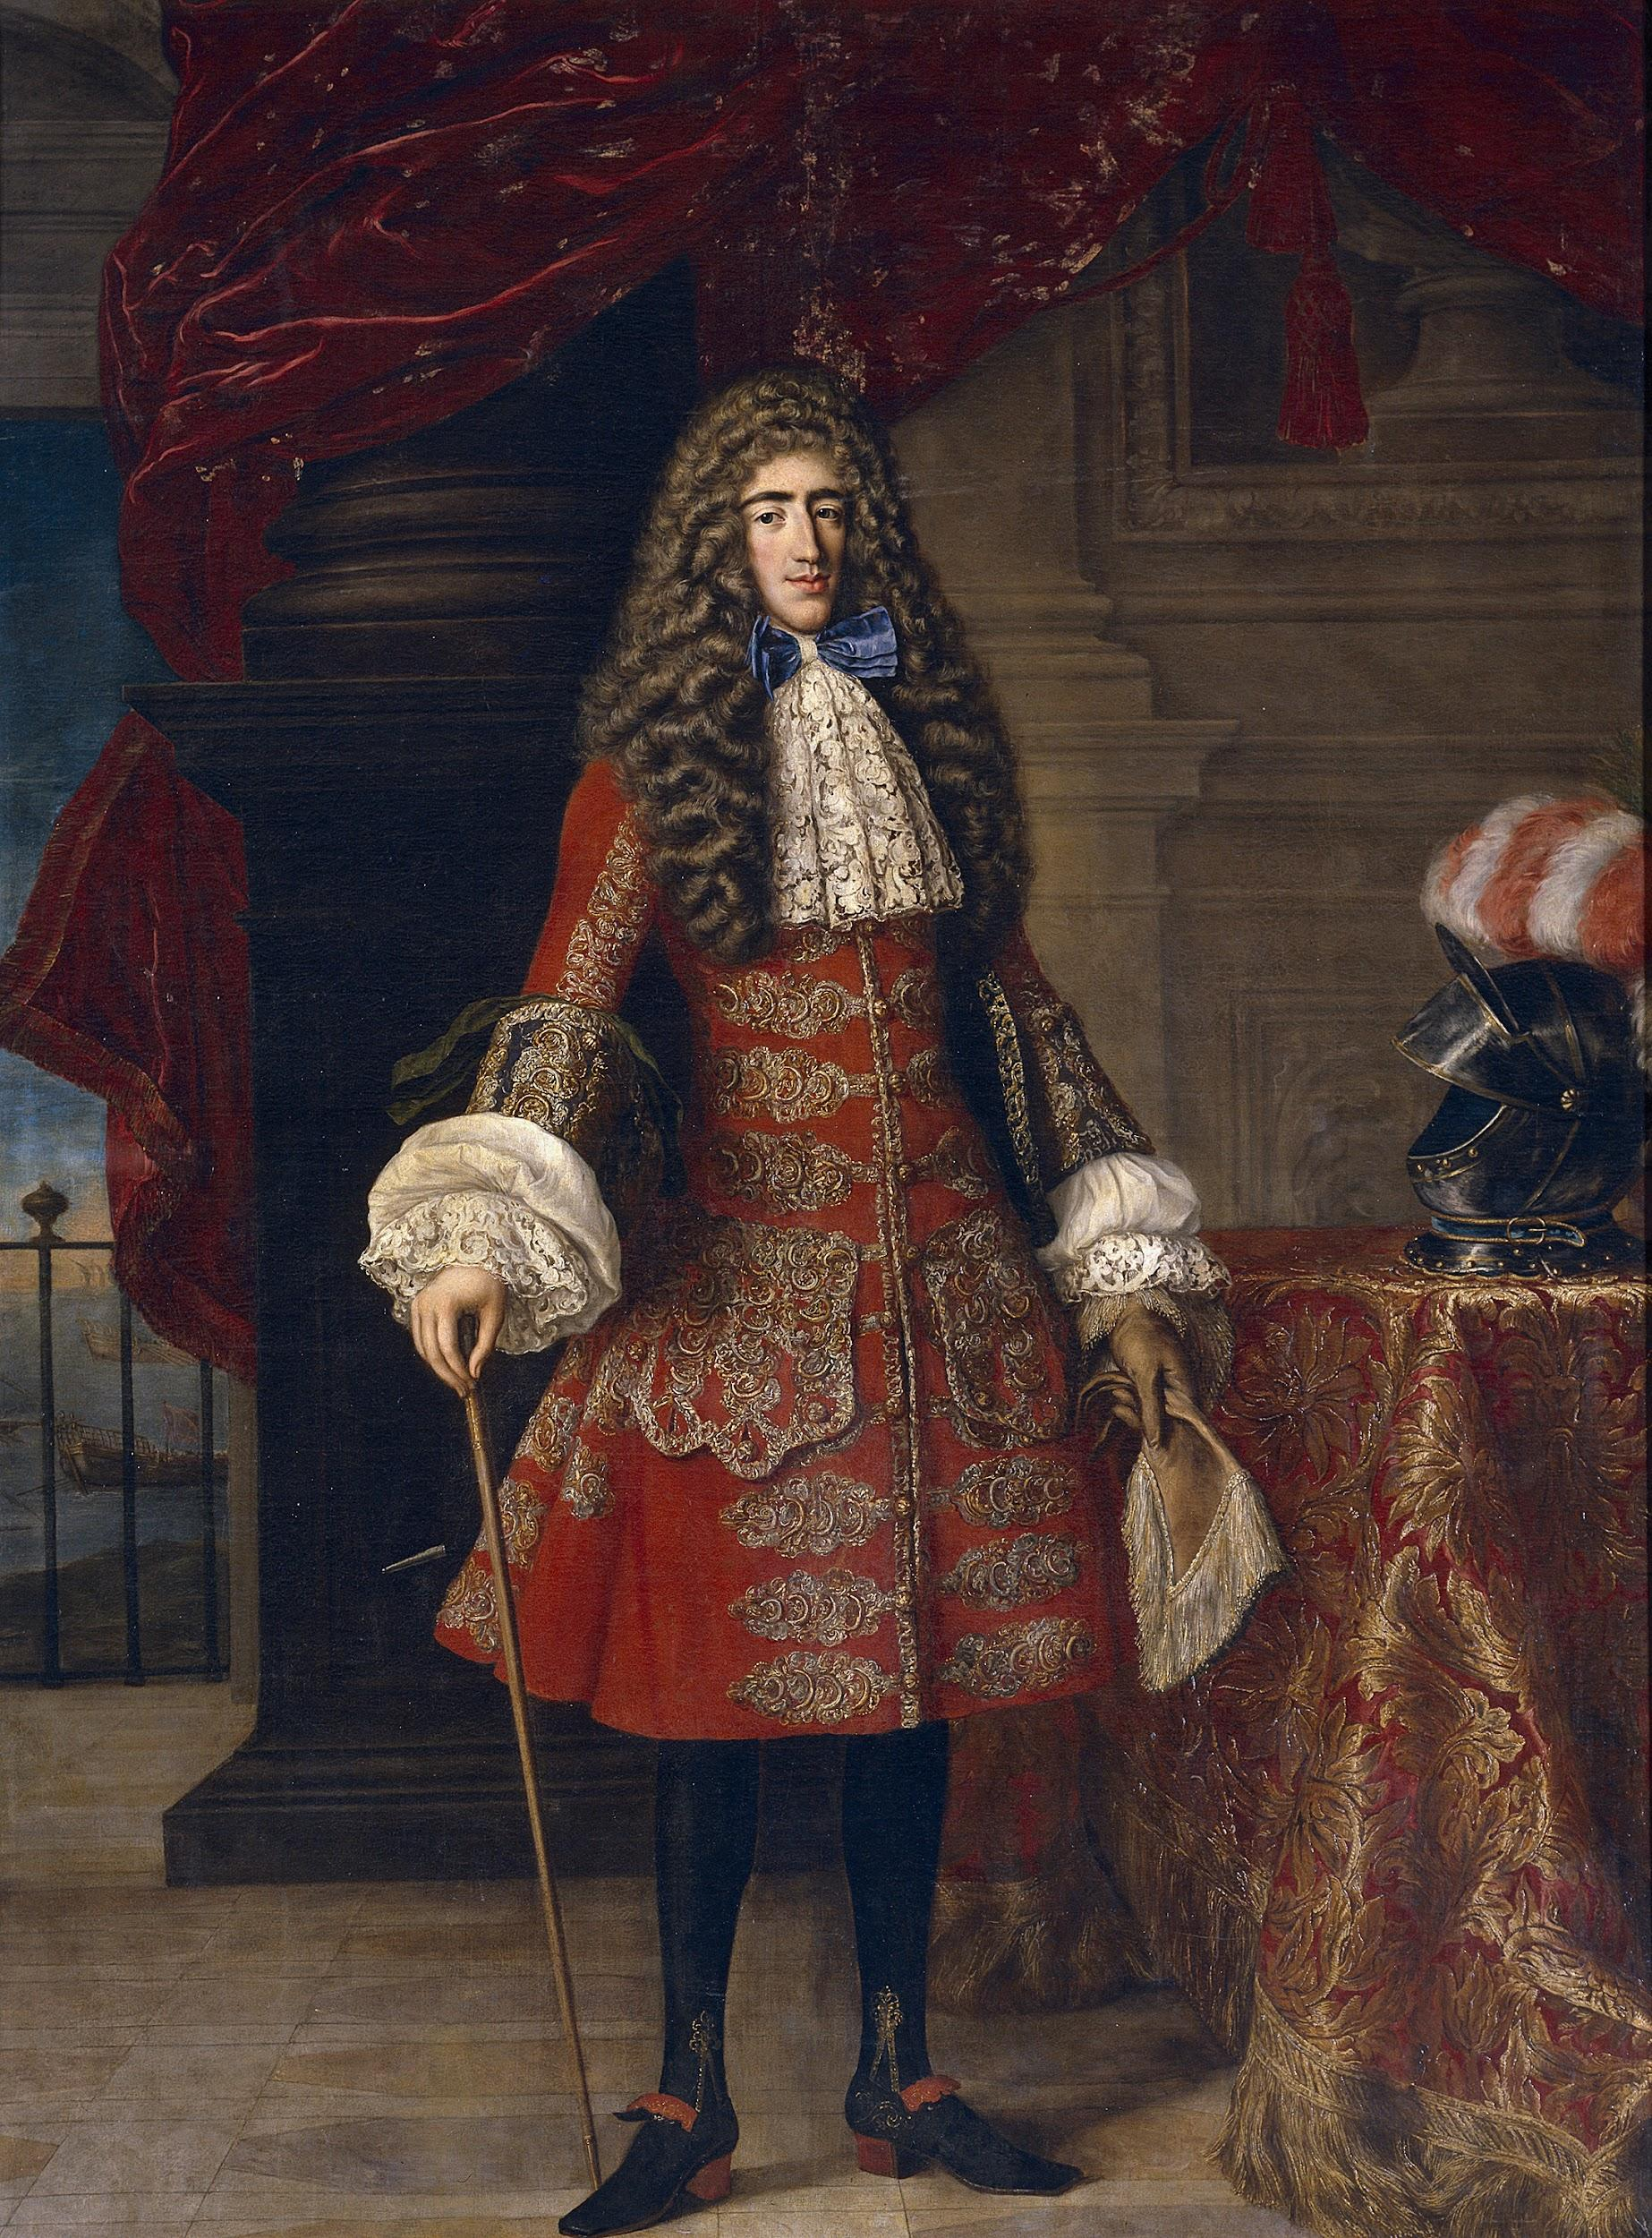

1. Justaucorps- Anna Ament

Justaucorps were luxurious coats that went all the way down to the knee. They were specifically worn by men and were most commonly seen among royalty. Another name for them was Surtouts. Because they were made for royalty, they were made with very expensive fabrics such as silk and velvet. Initially, they were made to be closed as one garment but later on came to be more open as a coat today might look like. They were formal and as such had many fancy details such as buttons, loops, etc.

<https://fashionhistory.fitnyc.edu/justaucorps/>

<http://www.fashionencyclopedia.com/fashion_costume_culture/European-Culture-17th-Century/Justaucorps.html>

1. Latchets- Brittany Pocock
2. Love Lock - Hannah Ferreira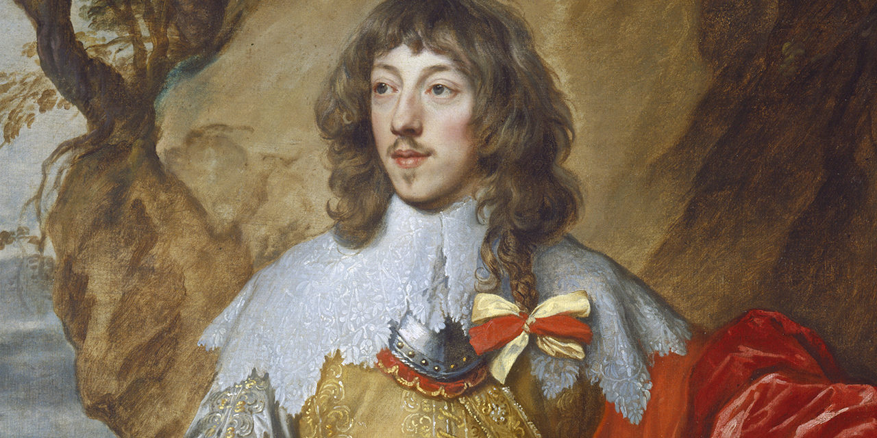

French and English men of fashion grew one lock of hair longer than the rest. This was known as a “love lock”. It was a romantic symbol of a lady’s affection. It was a sign of someone that was well-groomed. It was purposely turned around the nape of the neck so that it fell on the chest and was tied with ribbons. It also signified that they were worthy as a suitor or lover.

<https://www.rct.uk/collection/420895/portrait-of-a-man-perhaps-william-lord-compton-1568-1630-first-earl-of-northampton>

<https://fashionhistory.fitnyc.edu/love-lock/>

Book

1. Mantilla - Kimberly Tesam Moita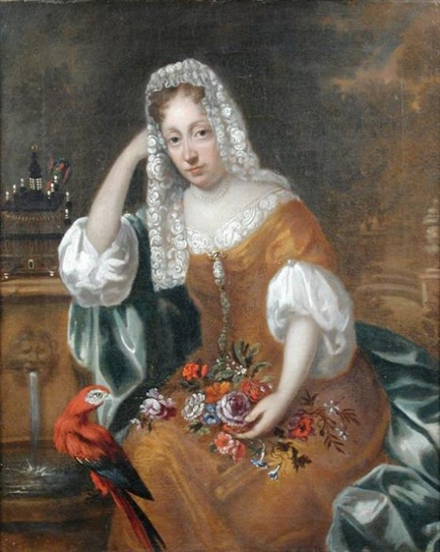

The mantilla was a lace headcovering that covered the heads of Catholic women. The length was regulated in Spanish society based on the status of the woman and also covered the face. It was considered to be a smaller version of the mantle worn by women during the medieval period that covered their hair. Made of lace, it became an almost everyday accessory in France besides how now it is used in Mass or was used for religious purposes later by the end of the 18th century. The color also dictated how the veil was viewed with white and ivory being purity and religious, black being seductive or a sign of mourning.

<https://en.wikipedia.org/wiki/Mantilla>

<http://www.centralencajera.com/mantilla/#:~:text=The%20use%20of%20a%20mantilla,by%20women%20of%20high%20society>.

<https://www.eyeonspain.com/blogs/luislopezcortijo/12336/The-Mantilla-a-very-Spanish-tradition.aspx>

1. Mantua, Manteau- Bailey Pinder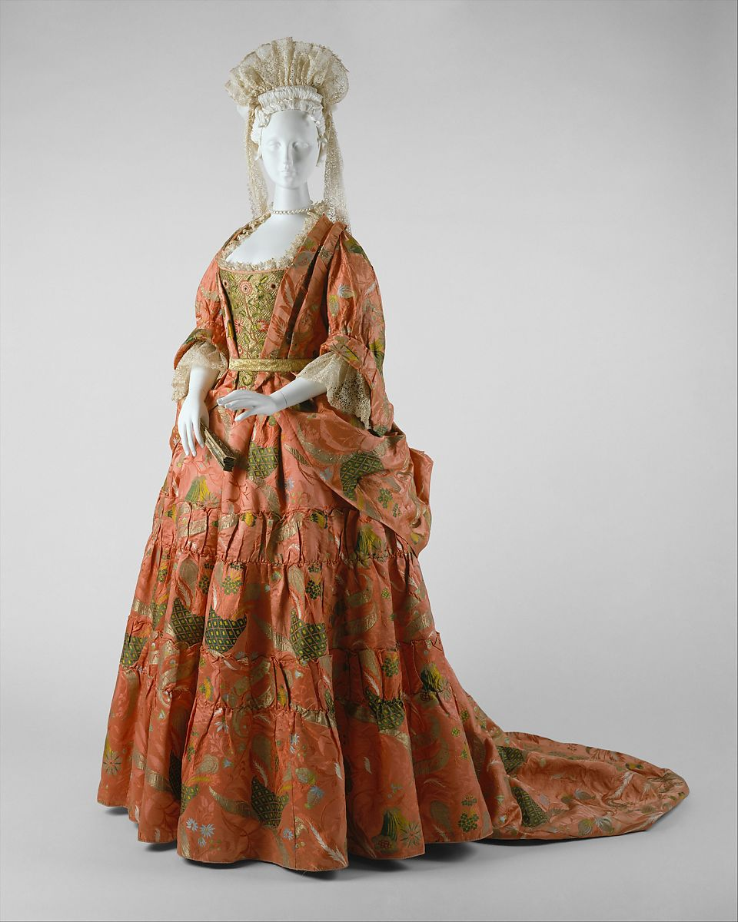

This style appeared in the late 1670s. Mantuas were much less restricting than the boned or stiffened bodices that had previously been worn by women. They were a loose-fitting gown that was draped rather than cut and believed to be derived from the construction of Middle Eastern robes imported to Europe. The draping of the fabric showcased the design of the silks much better than cutting. It kind of resembled a coat or a kimono. It would be worn over a matching corset and underskirt, with the mantua being folded back so the underskirt could be seen. It was originally an informal style and King Louis XIV even banned it at court because he considered it too informal, but it quickly grew in popularity and eventually came to be accepted.

<https://www.metmuseum.org/art/collection/search/81809>

<https://fashion-history.lovetoknow.com/clothing-types-styles/mantua>

Survey of Historic Costume pg 255

1. Modeste
2. Muckinder
3. Nappies
4. Pantofles- Marisol Dejesus 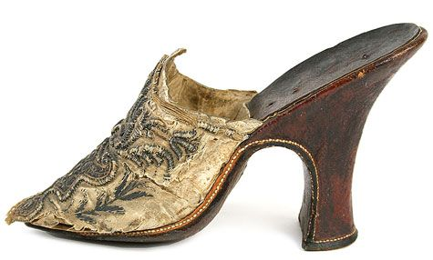

Pantofles are overshoes, loose shoes, high-less slippers, or mules. In the earliest days they were made of cork and were worn indoors and outdoors. Then in the 17th century they were made out of leather soles. So, the pantofles were to protect the front of the shoe when they go outside. Pantofles were knitted by hand or by machine out of wool or silk. Some will have embroidery or knitted decoration.

Sources:

Book pg. 256

<http://www.fashionencyclopedia.com/fashion_costume_culture/European-Culture-16th-Century/Pattens-and-Pantofles.html>

<http://aands.org/raisedheels/Heeldoc/written.php#:~:text=From%20the%20late%2015th%20to,not%20nearly%20as%20high%20as>

1. Petticoat Breeches- Zaya Weight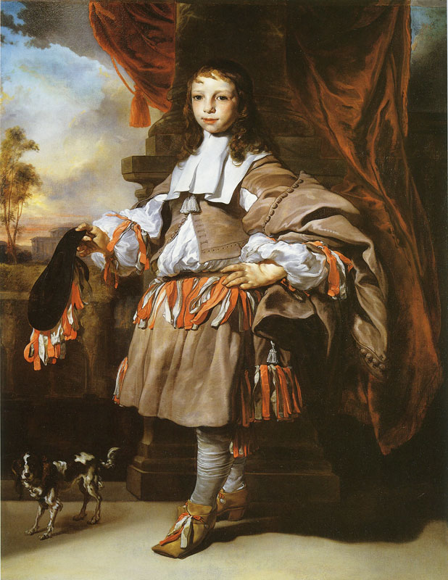

Petticoat Breeches, also known as rihnegraves, were a style of breeches worn by men. They were knee length & bifurcated like other breeches but they were cut full & resembled short skirts. They are similar to modern culottes. They were so wide you could put both legs through one hole & not notice for the whole day. They were also trimmed with loops & bows of silk ribbon.

**Sources:**

Survey of Historical Fashion- page 247

<https://en.wikipedia.org/wiki/Petticoat_breeches>

<https://twonerdyhistorygirls.blogspot.com/2009/07/petticoat-breeches.html>

1. Pinafore-Ida Johnson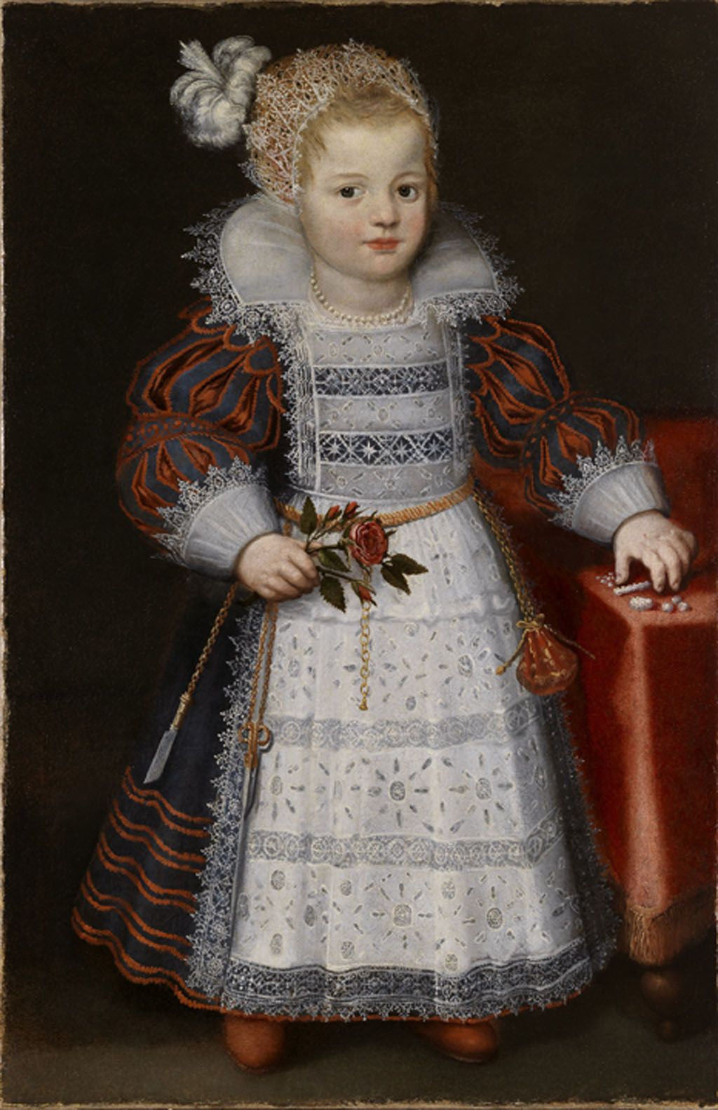

An apron that was pinned to the front of a garment or gown, especially used on children in place of a bib. <https://fashionhistory.fitnyc.edu/pinafore/> Book pg. 260

1. Plumper
2. Pomander Balls- Samantha Hooper 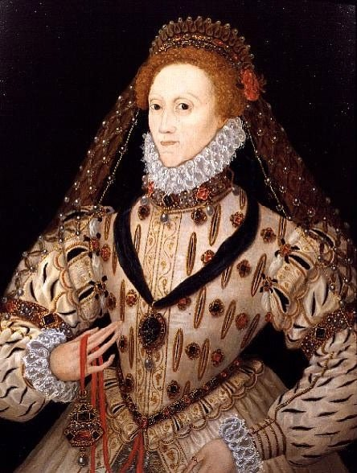

Pomander balls were small balls of perfume that were carried in decorated boxes and tied around the waist. Baths were pretty rare at this time and water was considered dangerous, so pomanders were a way to still smell good. Pomander comes from the French word for apple, pomme, and pomander balls were often shaped like apples.

<https://apercu.store/journal-archive/a-brief-history-of-fragrant-pomanders>

https://en.wikipedia.org/wiki/Pomander

1. Rhinegraves- Hailey Child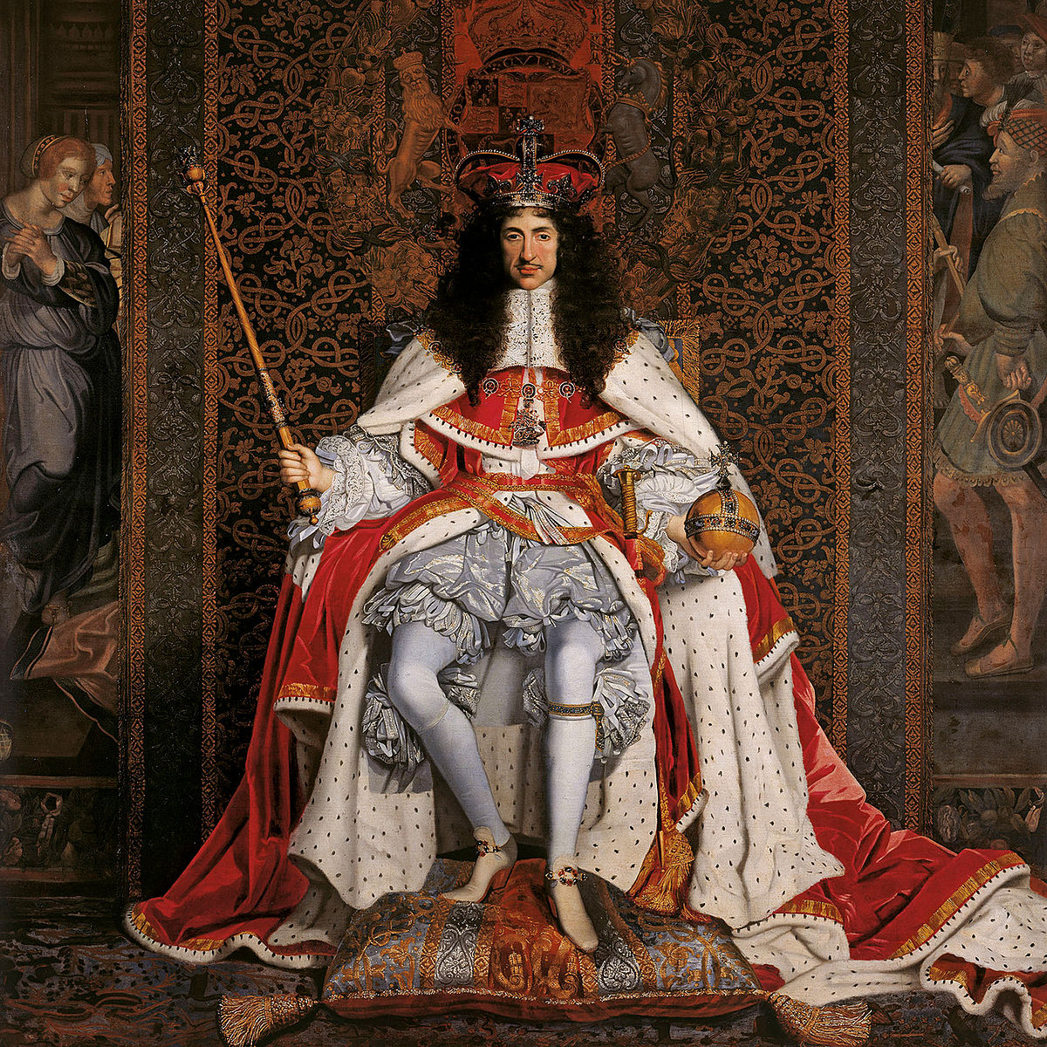

Rhinegraves are wide breeches worn specifically by men. They were often referred to as petticoat breeches and fastened above the knees. Rhinegraves were typically very full but gathered around the knee where they were typically decorated with ribbons or lace. Over time they became less and less full and were eventually replaced by tight fitting stockings.

<https://www.britannica.com/topic/rhinegraves>

Book

<https://en.wikipedia.org/wiki/Rhinegraves>

1. Ribbons of Childhood - Irelynd Preece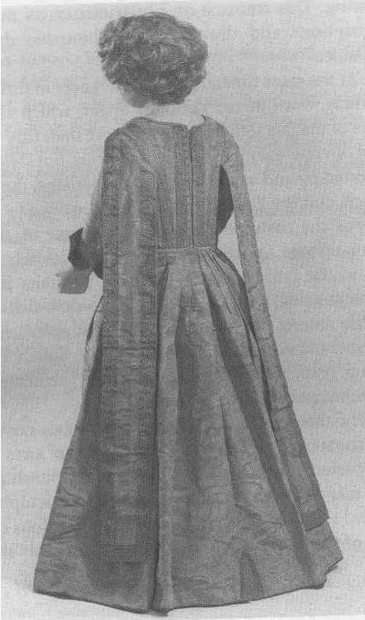

Ribbons of Childhood were two flat ribbons that descended down the back of children's clothing from the shoulders. These were attached to the shoulders of their clothing once the child could walk. The purpose of these ribbons was to aid the mother in helping the child stay vertical, as well as keeping the child in relative distance. However, Aries, who was a philosopher in the 17th century, argued that these “ribbons of childhood” were a stylized form of hanging sleeves that were part of the medieval times, but for the form of this era.

Sources:

Textbook page 259

<https://www.ehow.co.uk/info_8050557_ribbons-childhood-17th-century.html>

<https://quizlet.com/194028198/17th-century-fashion-flash-cards/>

1. Secret
2. Slap Soles - Savannah Jeppson

Slap soles were attached to the shoe only at the sole of the shoe. This gave its uncanny name of “Slap Soles” because it would slap the floor as the wearer walked. It’s functional purpose was to help the heel not sink into the soft ground.They were worn mostly in the first half of the 1600’s. The women’s slap sole became connected at both the heel and sole to make it easier to walk in. Sources: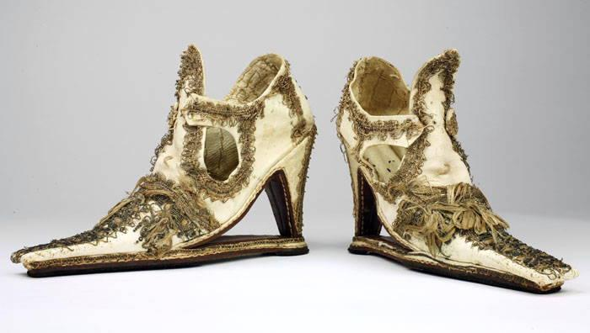

<https://allthatsinteresting.com/historys-fascinating-footwear/2>

The Book

<https://twonerdyhistorygirls.blogspot.com/2010/08/noisy-height-of-fashion-slap-sole-shoes.html>

1. Stomacher - Abby Fluckiger

A stiffened panel of fabric, often in an inverted triangle shape. It would be pinned to the front of the gown (in the right-side image, the tabs on the sides would have been pinned to the stays or underlayer, so the stomacher itself wouldn’t be damaged), or slid into the gap behind the lacings on an open gown or set of stays (if stays was the outer garment worn). It was for modesty and for fashion, as stomachers could be elaborately embroidered, and they could contain the busk, which helped achieve the fashionable silhouette.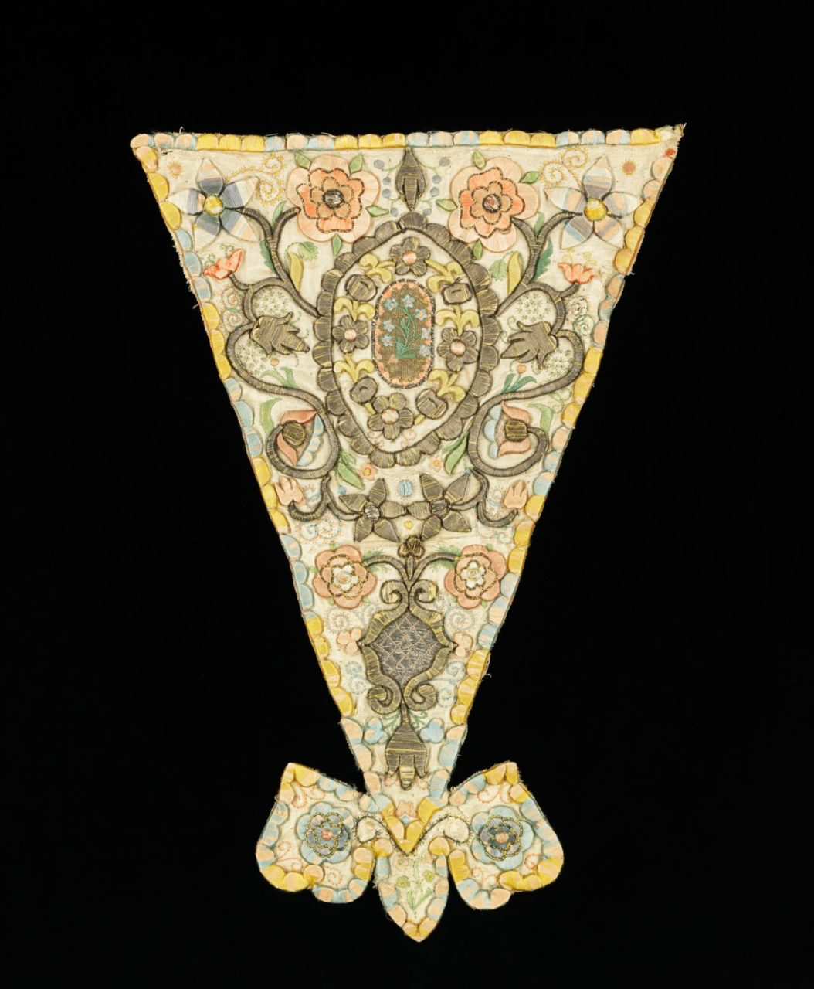

Sources:

Textbook pages 212, 218, and 221

<https://collections.vam.ac.uk/item/O364609/stomacher-unknown/>

​​<https://fashionhistory.fitnyc.edu/stomacher/>

1. Straight soles, Straights
2. Surtout
3. Tricorne
4. Vest- Andrea Lazaro Hernanez 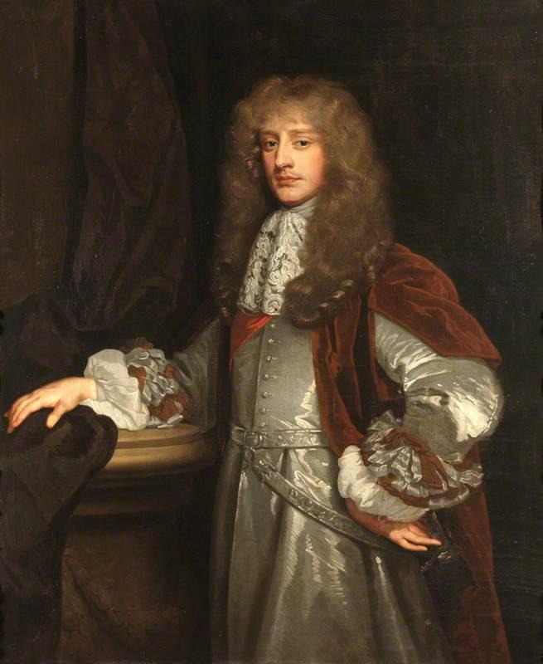

The vest was first introduced by King Charles II of England because he was trying to outdo the fashion of King Louis XIV of France. The idea of the vest was taken from an English traveler who was inspired by what was worn at the Persian Court. King Charles II vowed to wear this piece of clothing for the rest of his life, though he didn’t fulfill that promise. The vest worn during the 17th Century was the introduction of the three-piece suit that men wear nowadays.

Sources:

Survey of Historic Costume page 248

<https://fashionhistory.fitnyc.edu/vest-waistcoat/>

<https://fiveminutehistory.com/five-minute-guide-waistcoats/>

1. Virago Sleeve Lena Kawakami 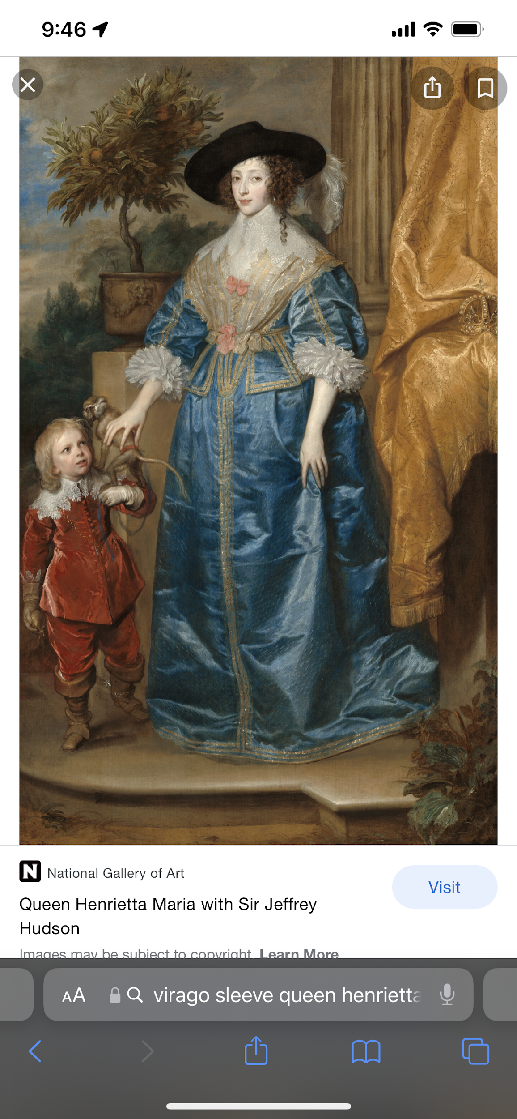

A virago sleeve is a sleeve that is panned and tied in a series of puffs. Virago sleeves can also be slashed and sometimes embroidered <https://trc-leiden.nl/trc-needles/individual-textiles-and-textile-types/daily-and-general-garments-and-textiles/virago-sleeve>

1. Waistcoat - Aubrey Reidhead

This was appropriated from some traditional dress of Eastern European and Islamic countries and made into a sleeveless garment that had the bright colored ones popularized by King Charles II who later pushed the popularity of the vest ([Wikipedia](https://en.wikipedia.org/wiki/Waistcoat#17th-18th_centuries)). The waistcoat was similar enough to the vest that it basically became interchangeable name-wise (pg 250), but this along with a coat and breeches made the typical outfit for men formally and informally dressed. The waistcoat would be shorter than the wearer’s coat and would often be made of colored silk ([Historical Menswear](http://www.historicalmenswear.com/1700s/)).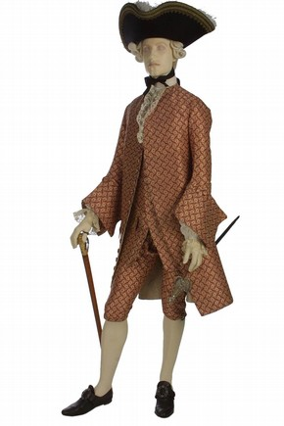

1. Whisk